About BMS to AVI converter
9th June 2005 Brans Technologies Inc.
The bms files generated by NVMS are NOT commonly used format
Brans support bms to avi conversion tools.
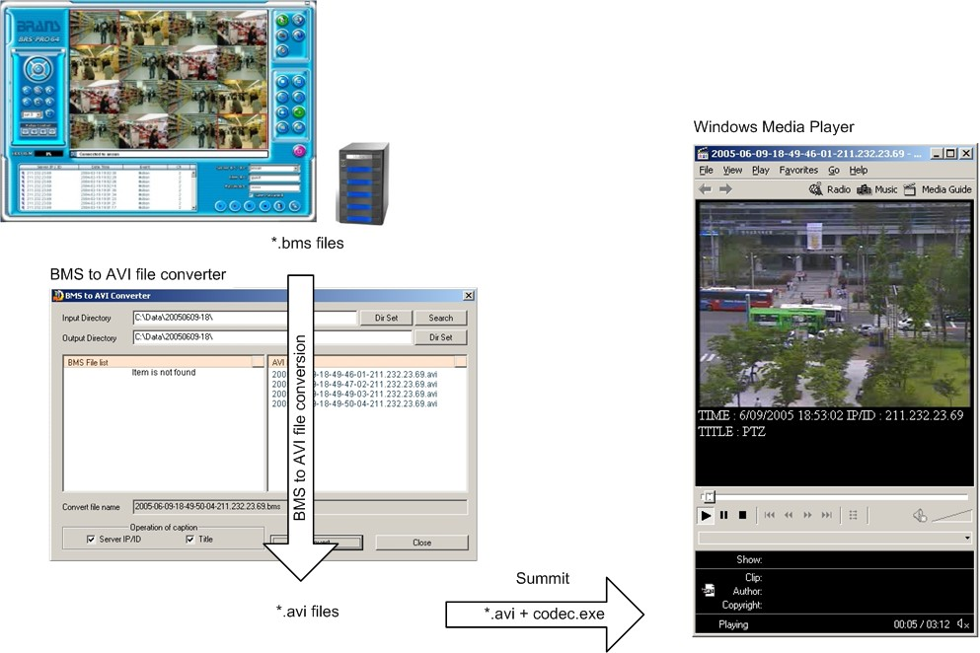

A BMS to AVI converter convert from bms files to avi files.
Converted avi files are NOT playback directly using Windows Media Player.
A “Codec.exe” should be installed prior to initial playback.
Once installed, there is no need to further installation.
Windows Media Player 9.xx is recommended. (Windows Media Player under 9.xx have little bit problem in zooming)
Conversion Procedure (After installation)
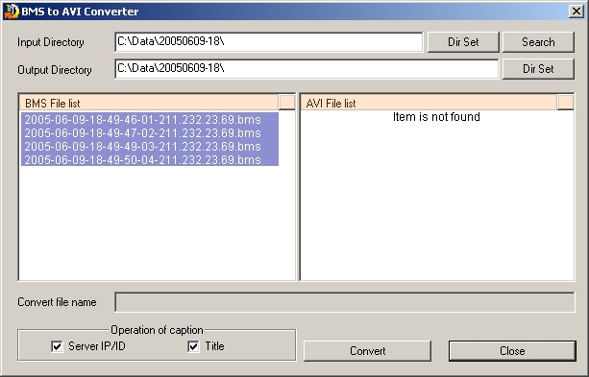
①
②
③
④
- Select Source directory where bms files exist.
- Click “Search” button to browse the bms files.
- Select the files to convert.
- Click “Convert” button to make conversion.
