Affecting Model# | VMAX IP 8CH & 16Ch (Bay Alarm Version)
Current Version
Released Date | 10/7/2016
Announce to | Internal

Note | 1. Supports Motion Recording for second generation Megapixel Cameras  - DWC-MF21M28T  - DWC-MF21M4TIR  - DWC-MF21M8TIR  - DWC-MD421TIR  - DWC-MD421D  - DWC-MV421TIR  - DWC-MV421D  - DWC-MB721M4TIR  - DWC-MB721M8TIR  - DWC-MB421TIR  - DWC-MV82WiA

Enhancements / Changes/ Fixes
Ref# | Description
001 | 1. Supports Motion Recording for second generation Megapixel Cameras
002 | 1. Second Generation Megapixel Camera Function Matrix with VMAX IP 8&16CH (Bay Alarm version)  - NVR 8CH & 16CH DVR SETUP  - CAMERA SETUP  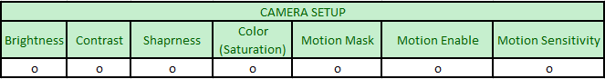  2) CAMERA ADVANCED SETUP  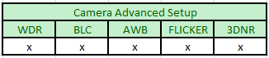  3) STREAM SETUP  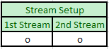  - NVR 8CH & 16CH WEB REMOTE SETUP  1) CAMERA SETUP  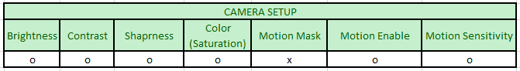  2) CAMERA ADVANCED SETUP  3)STREAM SETUP  O = Supported  X = Not Supported

Firmware Location
BAY ALARM VER 8CH and 16CH | VMAX IP 8 & 16CH FW
Login INFO | Username : dw Password : dw1234

Special Instruction/Comment
Following features will be available after second phase developing.
- NVR CAMERA ADVANCED SETUP
- WEB REMOTE MOTION MASK SETTING
- WEB REMOTE CAMERA ADVANCED SETUP

